Background: using 3D CNN and point-voxel models on simulated proton/neutron scattering data. If I input simplistic training cubes to a model, giving the geometry, density, and atomic number Z, can the model predict unseen geometries? I irradiate the cubes with 100 MeV protons in the form of a beam and investigate the resulting angular distribution and energy spectrum.
Simulation work (data collection): The data is gathered from Geant4 Monte Carlo simulations with several different geometries (explained later, see figure 1). Initially, I was looking at a square and hemisphere detector behind the farthest cube but found that including the entire 360 degree includes neutrons that are backscattered.
Started 3D-CNN model: CNN has 3 convolution blocks instead of flattening the entire input. The data is given as 36×36×36 arrays with two channels, density and Z. Empty space is 0, so the nonzero voxels give the geometry. The geometry is encoded with voxels 2.5 mm wide. Each cube is 1 cm, so each cube is 4 voxels wide. The entire staging area for the cubes is 9×9×9 potential cubes wide so that the beam hits the center of the initial cube.
Initial tests: I used aluminum, copper, lead, and tungsten as cube materials. First thing, I wanted to test was if the model can learn at all. Pretty successful using simple 2 cube arrangements and testing on unseen arrangement combinations. Then, I wanted to see how symmetries can be conserved within the model. The model is +z direction translational symmetric (which is the direction of the proton beam) and rotational +z symmetric. Both are invariant and we expect the same spectrum and distribution post movement.
Used data augmentation and a canonicalization method so that all orientations are the same and wanted to compare the two. Both performed much better than a model not aimed at the symmetries. Training was roughly several hundred for both. Canonicalization is exact symmetric (basically frame averaging from class) so it seems more stable?
Also wanted to see if it could scatter correctly off a material it hadn't seen. I used a single silver cube (Z = 47, between Cu and W). Seems okay at predicting it, will do more tests soon. I think with only 4 materials inputted; it doesn’t know the difference between Z and density yet.
Future Direction: Want to consider adding physics knowledge into the loss function (currently sum of angular and spectrum loss) because we know some of the nuclear physics behind attenuation and stopping power behind materials (Bethe-Bloch).

Haven’t done much model tuning. I saved validation data to tune but it seemed more important to see differences in how the models are. Will do this later, in a somehow unified manner to compare.
See figure 2 but the neutron distribution is always very similar so it’s difficult to tell if model is improving or not. Currently, I compare loss values and results with an averaged spectrum/distribution, but may need to do something different to test the model.
Have also requested Savio access from my advisor so training will be much faster in the future. Currently my mac is struggling and every train takes several hours.
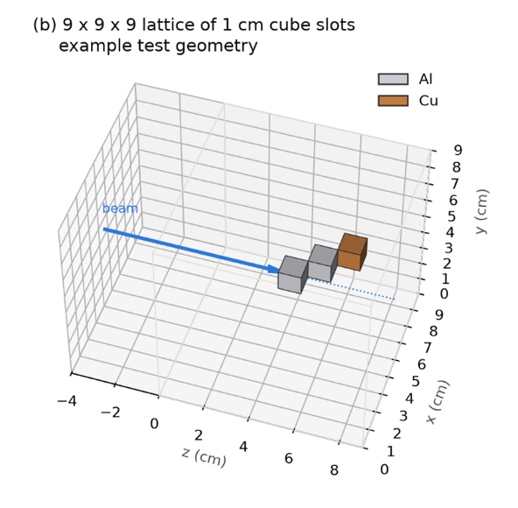 Figure 1: example simulation set up with 3-cubes
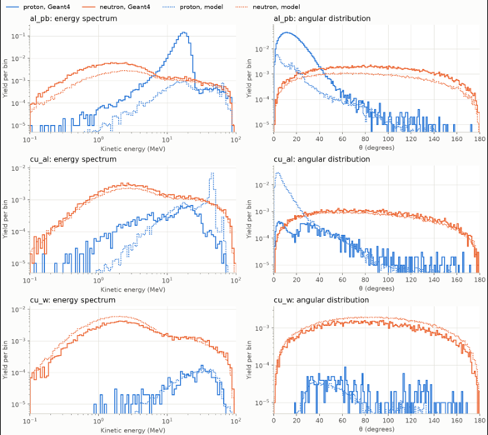 Figure 2: predicted vs simulated neutron and proton energy spectrum and angular distribution

